**Step by Step Instructions:**

**Step1**: install Eclipse from below given URL

<https://www.eclipse.org/downloads/>

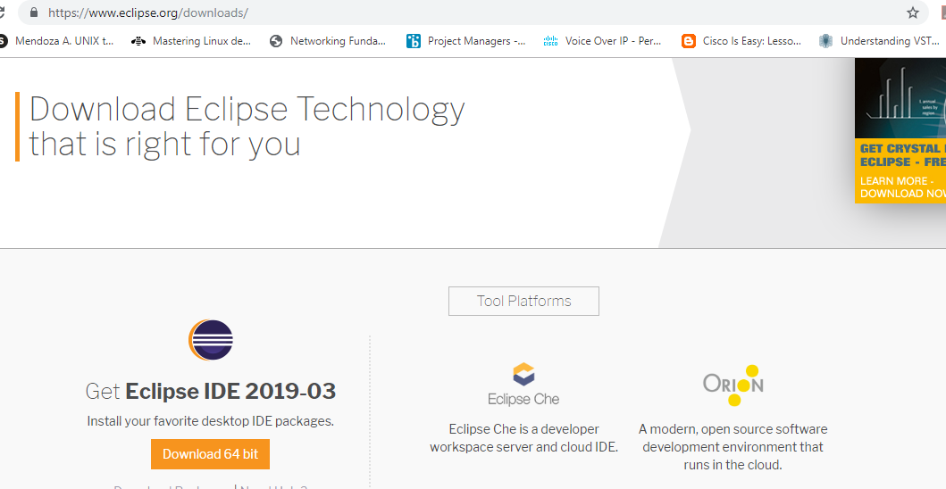

**Step2:** Download and save Selenium from below given URL

<https://www.seleniumhq.org/download/>

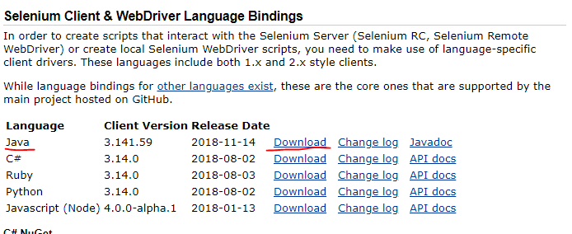

Note: Files downloaded from Selenium will be imported in Eclipse, more details in Step3.

**Step3**: Import Selenium jar files into Eclipse

Right click on Project 🡪Click on Properties🡪Click on Java Build Path🡪Click on Libraries🡪

Click on Add External jars from Selenium folder (downloaded in Step2)🡪Apply🡪Apply and close.

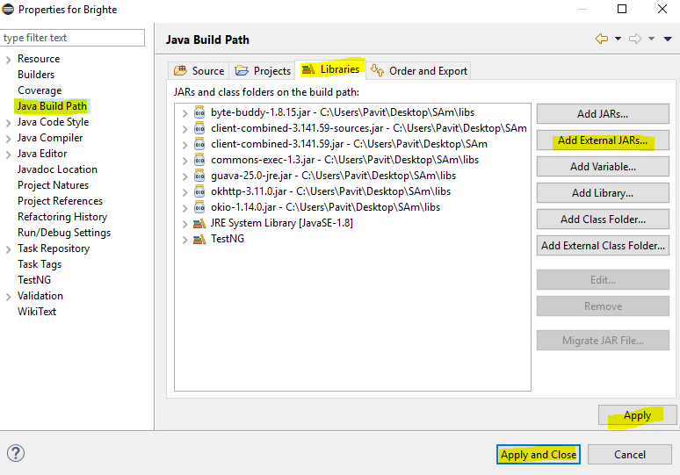

**Step5**: Follow below steps in order to create Project

File🡪New🡪java Project🡪Enter a project name

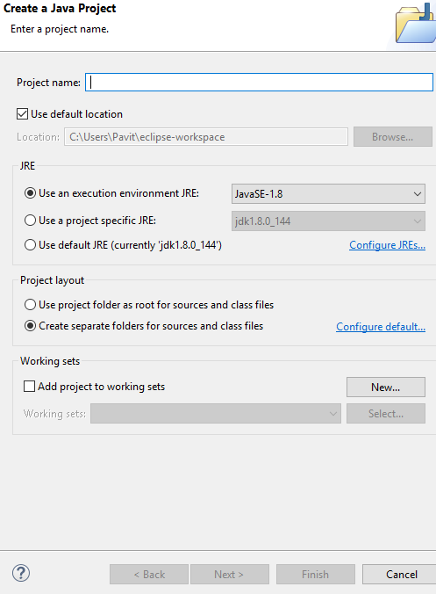

**Step6: Below steps to create package**

Right click on Project🡪New🡪Package🡪Enter Package Name

**Step7: Below steps to create class**

Right click on Package🡪New🡪Class🡪Enter Class Name

**Step8: Start coding as per Forms**

Attached code for the reference



**Step9:** TestNg Installation(For running test cases and to run assert)

In Eclipse, click on Help-🡪Click on Install New Software🡪Add🡪TestNG:Name🡪Give location as http:llbeust.com/eclipse🡪Click on Okay🡪Select TestNG🡪Next🡪accept🡪Ok

## Step10: Test case using annotations in order to tun assert

a)Click File 🡪 New🡪>[Java](https://www.guru99.com/java-tutorial.html) Project

**b)** Type "FirstTestNGProject" as the Project Name then click Next.

c) Import the TestNG Libraries onto our project. Click on the "Libraries" tab, and then "Add Library"

d) On the Add Library dialog, choose "TestNG" and click Next and then click finish.

e) Add the JAR files that contain the Selenium API. These files are found in the Java client driver that we downloaded from <http://docs.seleniumhq.org/download/> while installing Selenium🡪Add all external JARs onto your screen

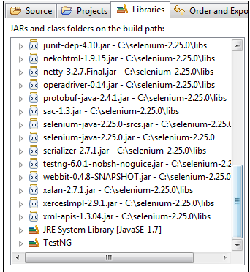

f) Click Finish and verify that our FirstTestNGProject is visible on Eclipse's Package Explorer

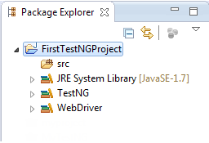

**Step11:** Steps to create a new TestNG file

a)Right-click on the "src" package folder then choose New > Other

b) Click on the TestNG folder and select the "TestNG class" option. Click Next.

c)Enter Source, Package and lass name🡪Click on Finish

### **Step12**: Running the Test

To run the test, run the file in Eclipse. Results will be provided in the Console window and the other on the TestNG Results window.

Attached herewith Test NG code

## 

## Step13: Reports will be generated in Test NG